**Supplementary Figures**

Figure S1. Pairwise comparison of susceptible (Farm 1) and either moderate or high ivermectin resistant parasite populations on US farms. 2

Figure S2. Pairwise comparison of susceptible (Farm 9) and either moderate or high ivermectin resistant parasite populations on US farms. **3**

Figure S3. Frequency of Phe167Tyr and Phe200Tyr variants of beta-tubulin isotype 1 associated with benzimidazole resistance on US farms **4**

Figure S4. No evidence of ivermectin selection on beta-tubulin isotype 1 resistant alleles in the genetic cross or US farms **5**

Figure S5. Multiple sequence alignment of Clade V orthologs of acetylcholine receptor subunit acr-8. **6**

Figure S6. Consistent evidence of selection on the chromosome 5 locus with respect to direct versus indirect measurements of genetic diversity after treatment **7**

Figure S7. A higher number of L3 per pool helps to increase the resolution of the peaks of differentiation **9**

## 

## 

#### Figure S1. Pairwise comparison of susceptible (Farm 1) and either moderate or high ivermectin resistant parasite populations on US farms.

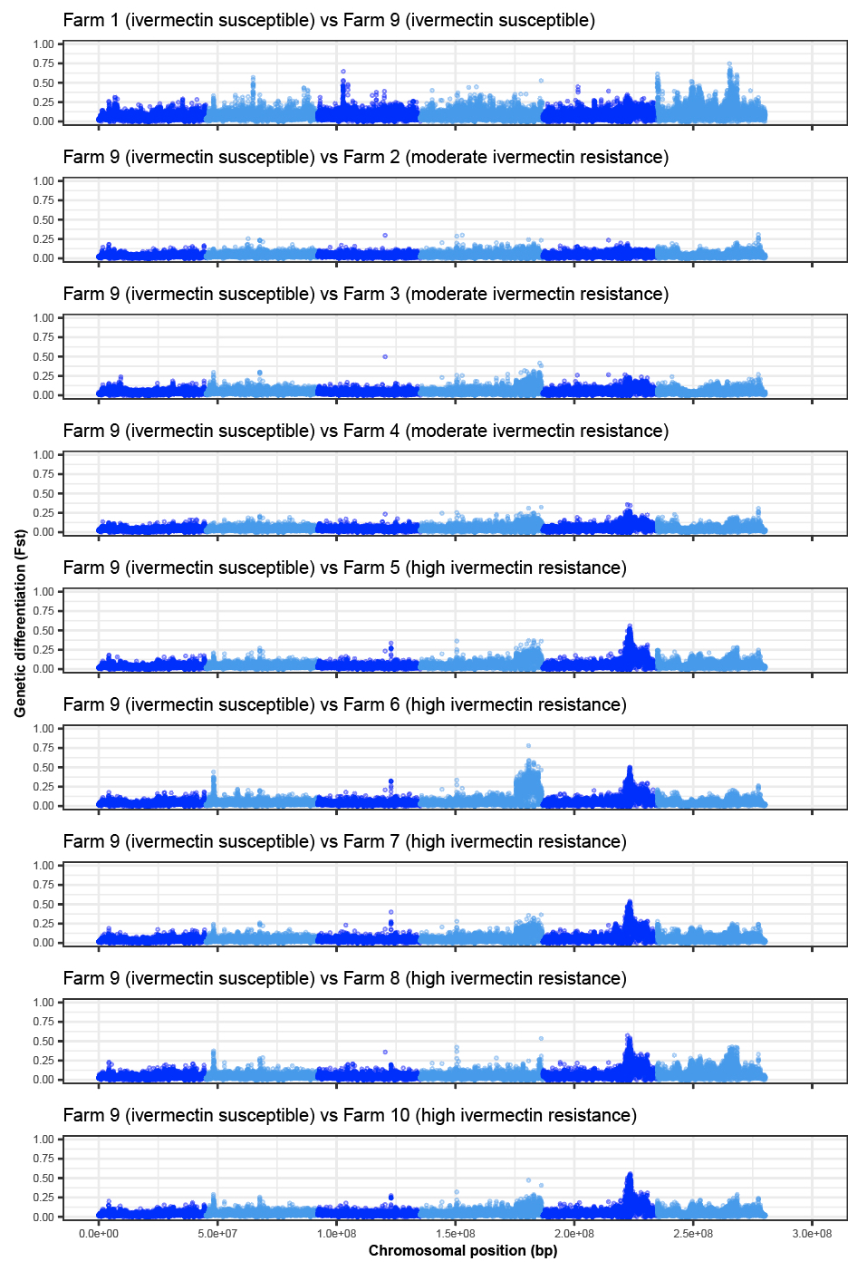

#### Figure S2. Pairwise comparison of susceptible (Farm 9) and either moderate or high ivermectin resistant parasite populations on US farms.

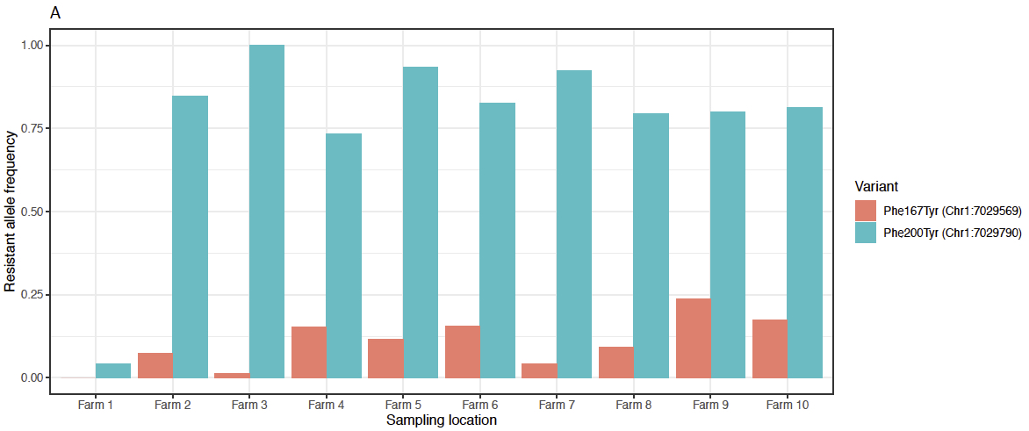

#### 

#### Figure S3. Frequency of Phe167Tyr and Phe200Tyr variants of beta-tubulin isotype 1 associated with benzimidazole resistance on US farms

WGS estimation of Phe167Tyr and Phe200Tyr variant frequencies from *H. contortus* L3 on 10 US farms. Worms from Farm 1 are phenotypically susceptible to benzimidazoles, however, all are farms are phenotypically resistant base on DrenchRite dose-response assays.

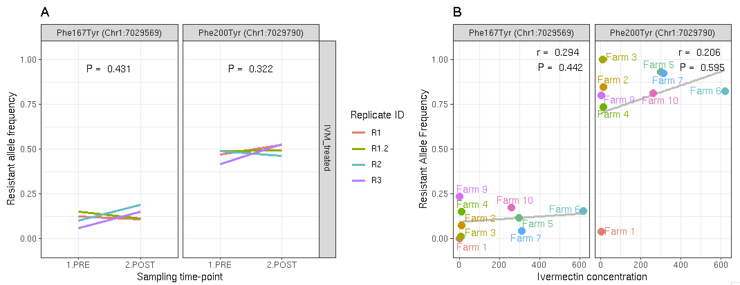

#### Figure S4. No evidence of ivermectin selection on beta-tubulin isotype 1 resistant alleles in the genetic cross or US farms

1. WGS estimation of Phe167Tyr and Phe200Tyr variant frequencies from *H. contortus* L3 collected the pre- and post-ivermectin treated animals of the cross. Neither variants showed a significant change in variant frequency, measured using a paired t-test. The p values are shown.
2. WGS estimation of Phe167Tyr and Phe200Tyr variant frequencies from *H. contortus* L3 and their correlation with drench rite measurement of ivermectin resistance on 10 US farms. For both variants, no significant correlation was identified. Pearson correlation coefficient (r) and p values are shown.

## 

## 

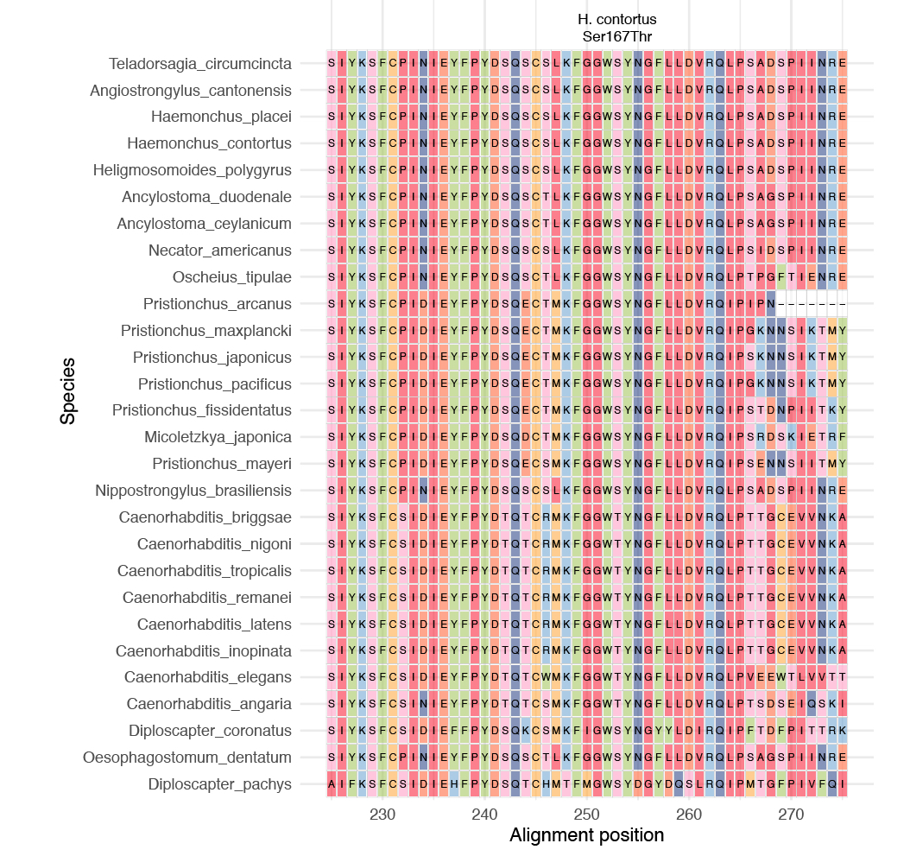

#### 

#### Figure S5. Multiple sequence alignment of Clade V orthologs of acetylcholine receptor subunit *acr-8*.

A Ser167Thr variant in *Haemonchus contortus* (Ser position highlighted) correlates with levamisole resistance in the study. This multiple sequence alignment focused on alignment positions 225-275 surrounding the *H. contortus* Ser167Thr position demonstrates high sequence conservation of the Ser residue among all Clade V nematodes analysed, except for species within the Caenorhabiditis genus (which contain Thr).

## 

#### Figure S6. Consistent evidence of selection on the chromosome 5 locus with respect to direct versus indirect measurements of genetic diversity after treatment

1. Genome-wide analysis of genetic differentiation sampled between adult males (n= 40) directly exposed to and have survived treatment recovered by necropsy, and pretreatment L3 (n = 200) from the same generation.
2. The same genomic interval on chromosome 5 as shown in Figure 4 A, highlighting the smaller peak region.
3. Dose-response curve of ivermectin using larval development assay to determine the EC50
4. Genome-wide analysis of genetic differentiation between poorly developing L1/L2 stage larvae at EC25 and developing L3 at EC75

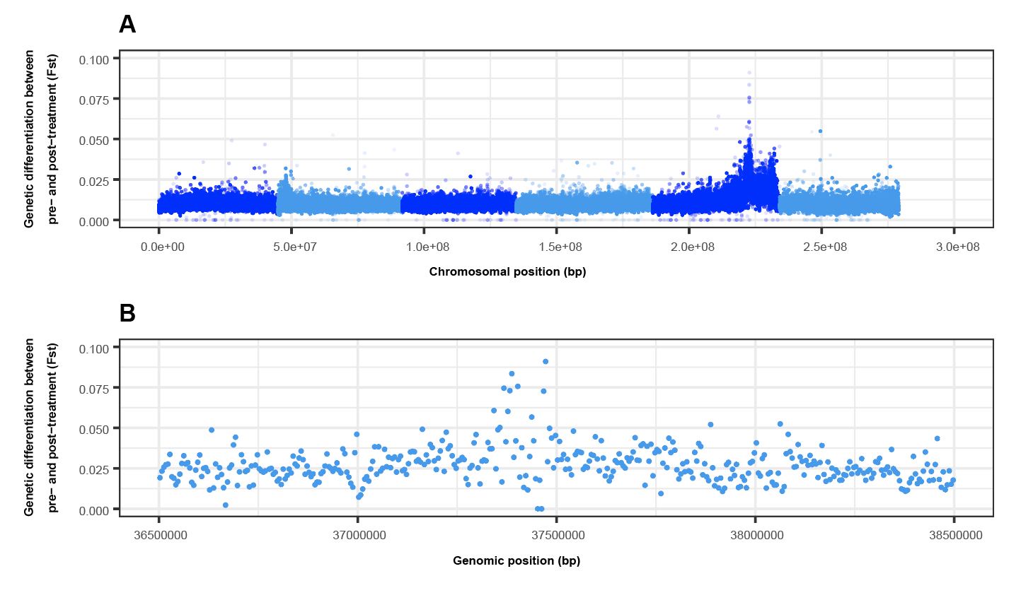

#### Figure S7. A higher number of L3 per pool helps to increase the resolution of the peaks of differentiation

1. Whole-genome comparison of pools of L3 (n = ~5000) pre- and post ivermectin treatment
2. The same genomic interval on chromosome 5 as shown in Figure 5 B, highlighting the smaller peak region as a result of the higher number of L3 pooled relative to the XQTL analysis (n = 200 L3 per pool).